CricGuyz: Scorer for unofficial matches

Problem:
There is very scoring system for Unofficial matches and it's very tedious to type score every ball.

Solution:
Scoring system which can be scored ball by ball with voice and keeps the record for players

Name:
CricGuyz: Scorer for unofficial matches

Types of users:
1) User

Module:

1) User Module
# Login and Registration
# Dashboard with Match Suggestion
# Can see scorecard
# Can search and see player's profile
# Create Match
# Ask and add players of squad
# Request fees from Players if not friendly
# Scoring for every ball with Voice recognition system
# Asked for permission to enter match
# Pay a fees if not friendly
# After match, player's scorecard should be updated

Functionalities

1. Login Page
# Login with Facebook, google and twitter
# Login using password
# Forget password

2. Sign up page
# Sign up with Facebook, twitter and google
# Sign up with Phone number
# Asked for OTP

3. Register Page
# Asked for Information
# Create a User

4. Navbar Functionalities
# Search for a player
# Start Match
# Show stats
# Open Quiz
# Take to performers
# Search for individual player

4. Home Page
# Shows Featured Matches
# Shows the cricketing post

5. Start a Match Page
# Select Team A
# Select Team B
# Start a match

6. Teams Page
# Shows My teams
# Shows Opponents Teams
# Search for the team
# Create a team
# Can see members of Team

7. Quiz Page
# Shows the question
# Gives the options to select

8. Player Stats/My stats
# Shows Player Information
# Batting stats
# Bowling stats
# Fielding stats

9. Performer Page
# Shows top performers of the week and month

10. Scorecard Page
# Shows ball-ball score
# Shows player score
# Can click on player to show player stats

11. Select Team Page
# Shows My teams
# Shows Opponents Teams
# Search for the team
# Create a team
# Can see members of Team
# Select team to start a new page

12. Score recording page
# Shows ball-ball score
# Shows player score
# Can click on player to show player stats
# Record score ball by ball with voice system

Database Design

Registration:
# phone_number
# password
# first_name
# last_name
# locality
# date_of_birth
# User_type_id

Batting:

# User_type_id
# Matches
# Runs
# Average
# Strike
# Sixes
# Fours
# High score
# 50s
# 100s

Bowling:

# User_type_id
# Wickets
# Runs
# Economy
# Average
# Strike
# BBM

Fielding:

# User_type_id
# Catches
# Run-out
# Stumping

Teams:
# id
# Team_id
# Player 1
# Player 2
# Player 3
# Player 4
# Player 5
# Player 6
# Player 7
# Player 8
# Player 9
# Player 10
# Player 11

Team List:

# Id
# Team_id
# Opp_my

Matches:

# id
# Match_id

Match_score:

# Match_id
# Innings
# Over
# Ball

Post:
# Id
# Image
# Likes
# Comments

Wireframes

Login:
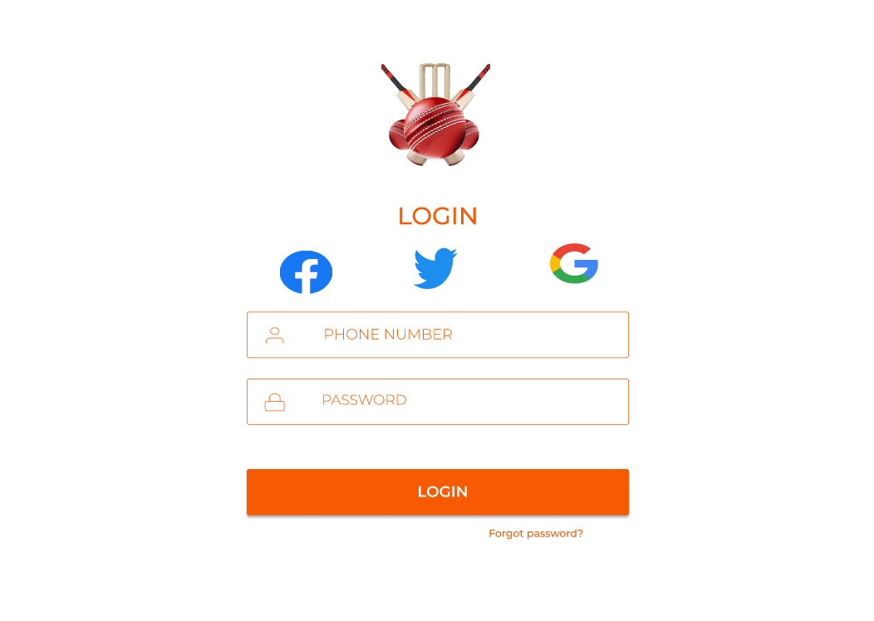

Sign up and OTP:
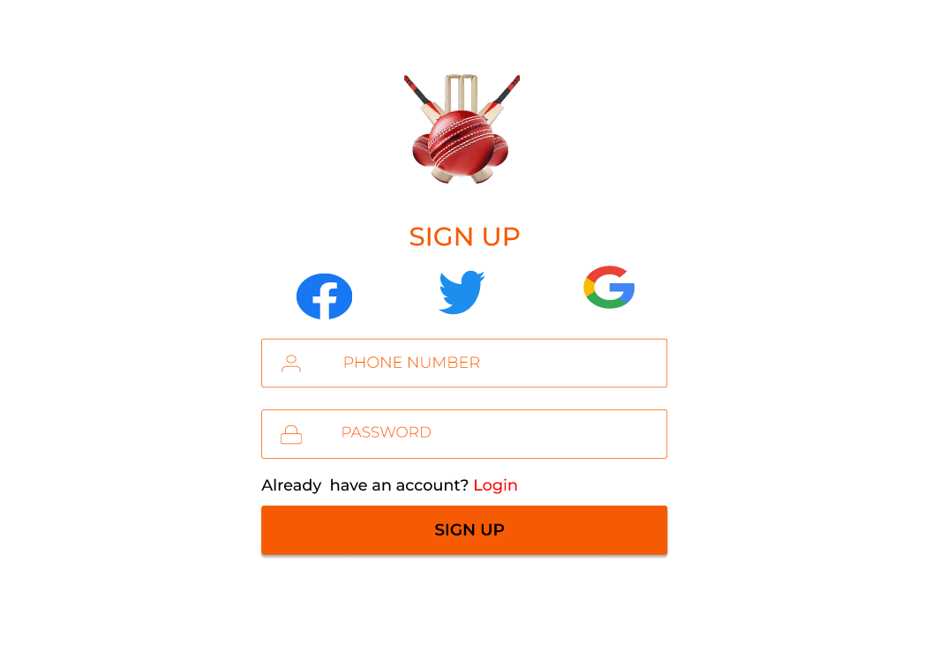
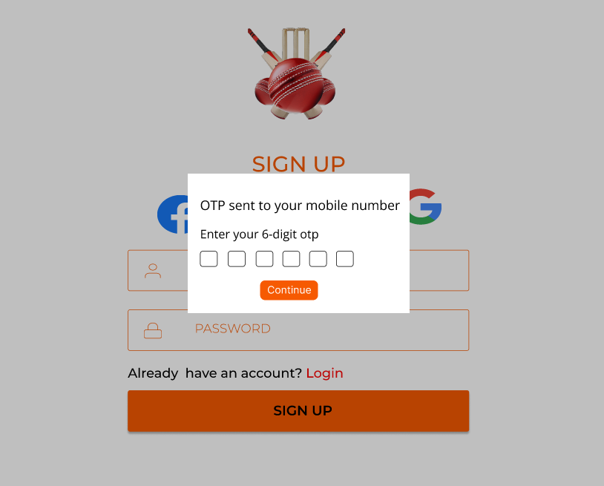

Registration
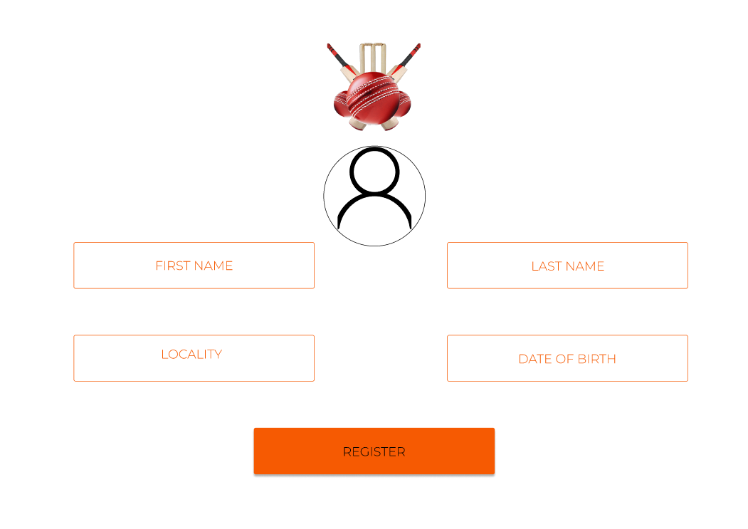

Top Performers

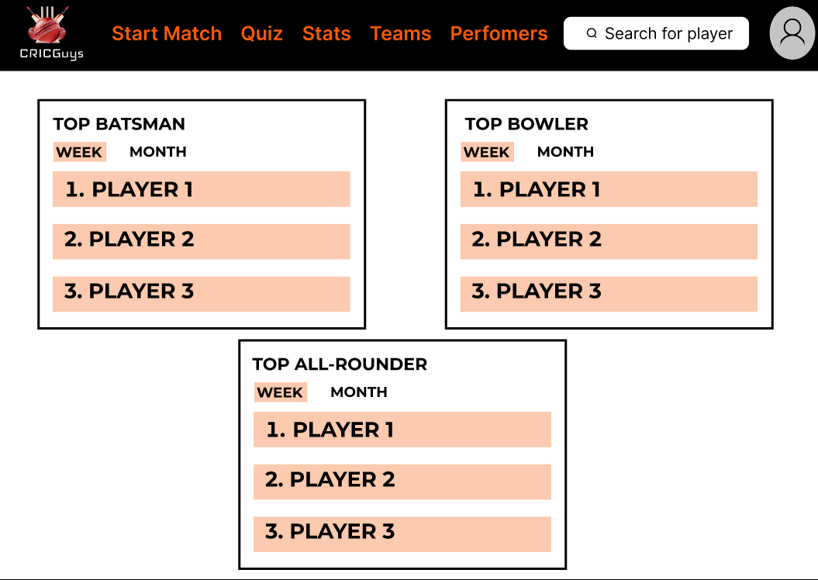

Quiz

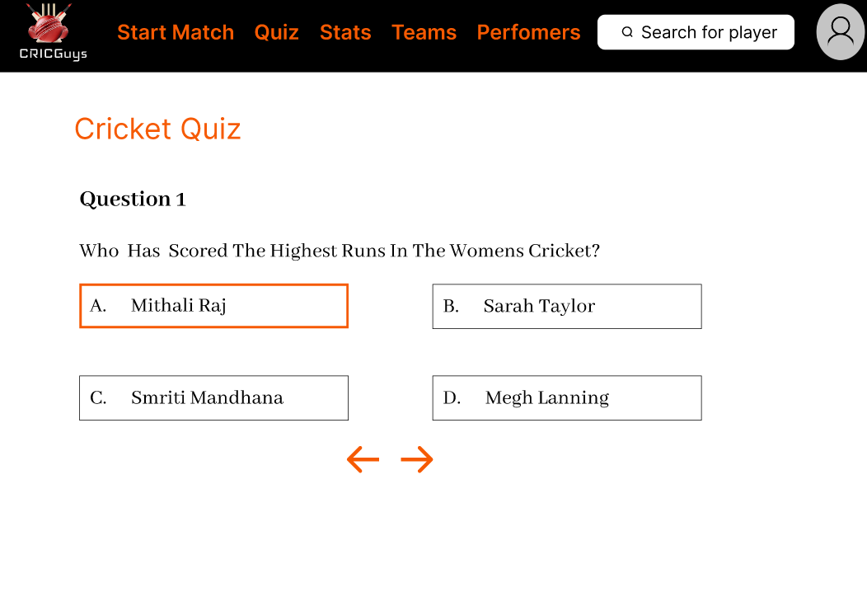

Start a match

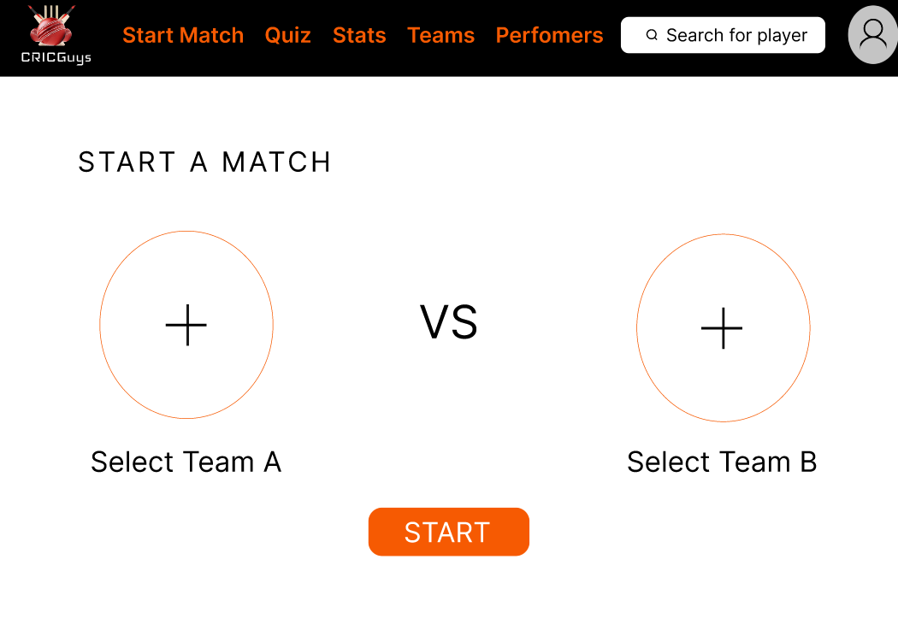

My Teams:

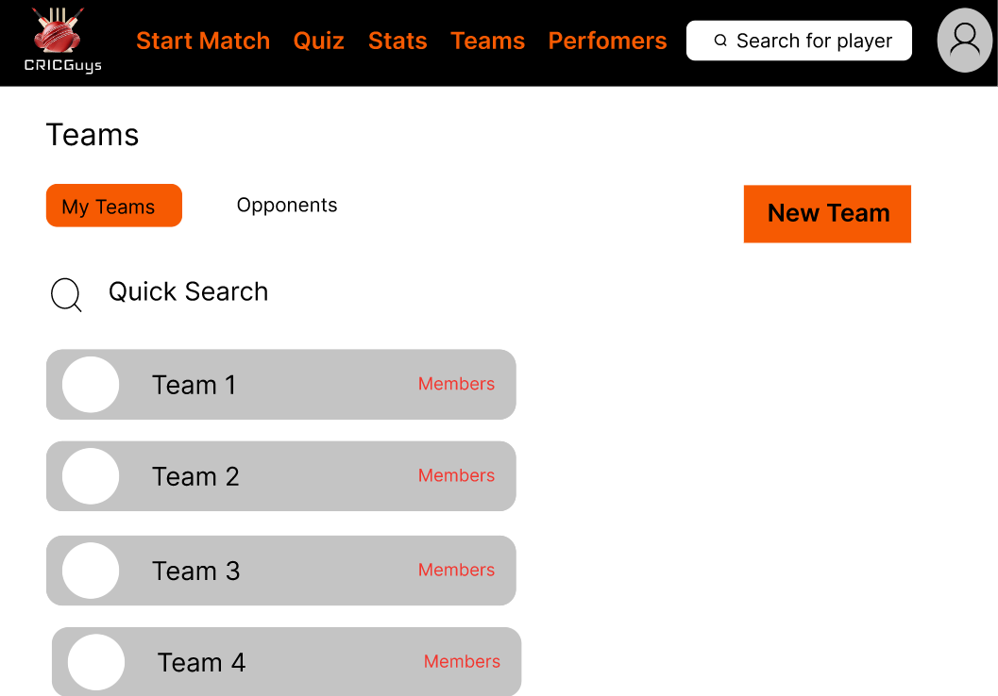

Home Page

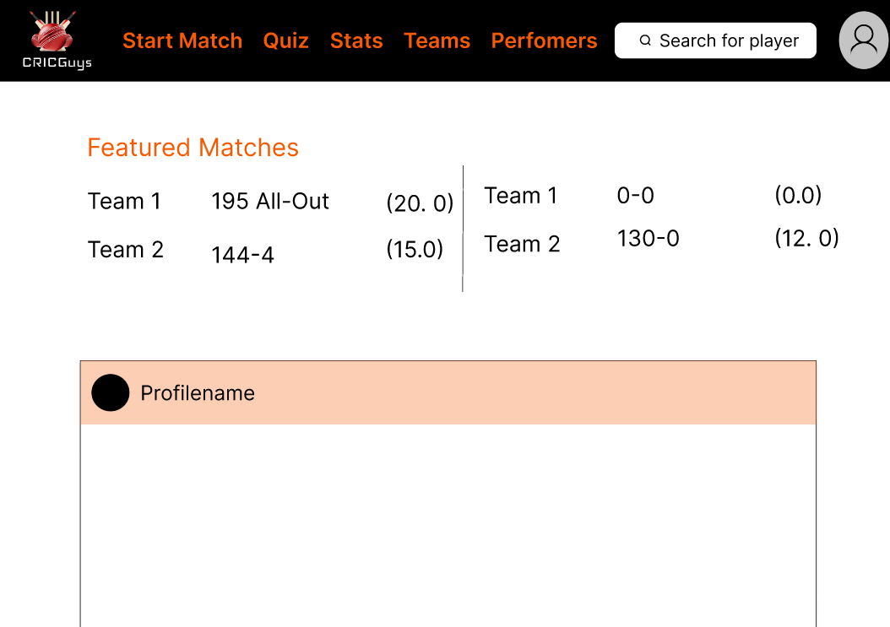


Select Team Page:

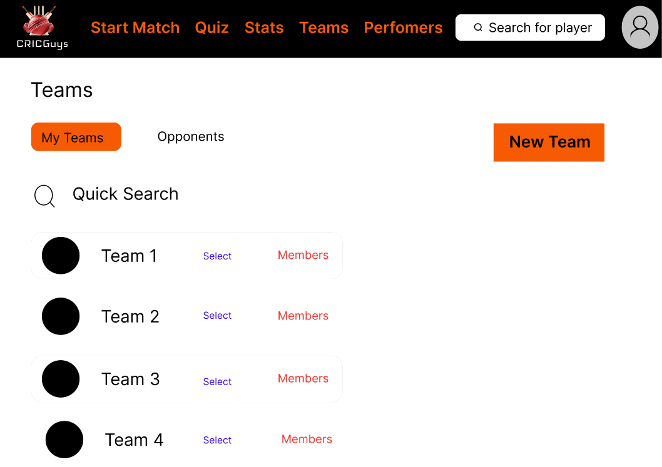

Scorecard Page

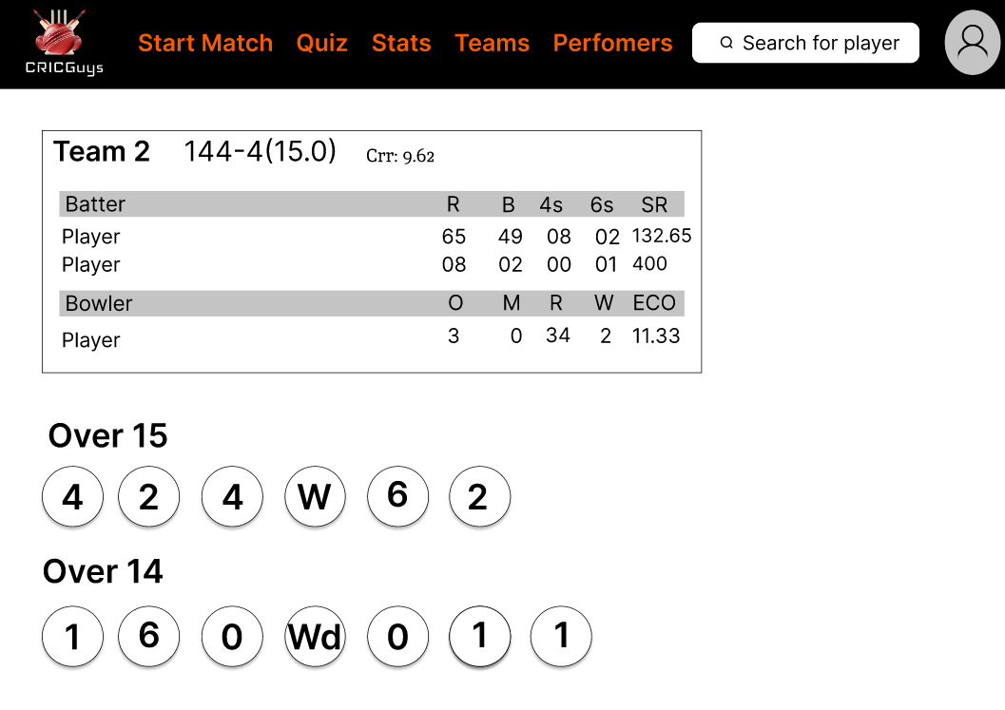

My Stats/Player Profile

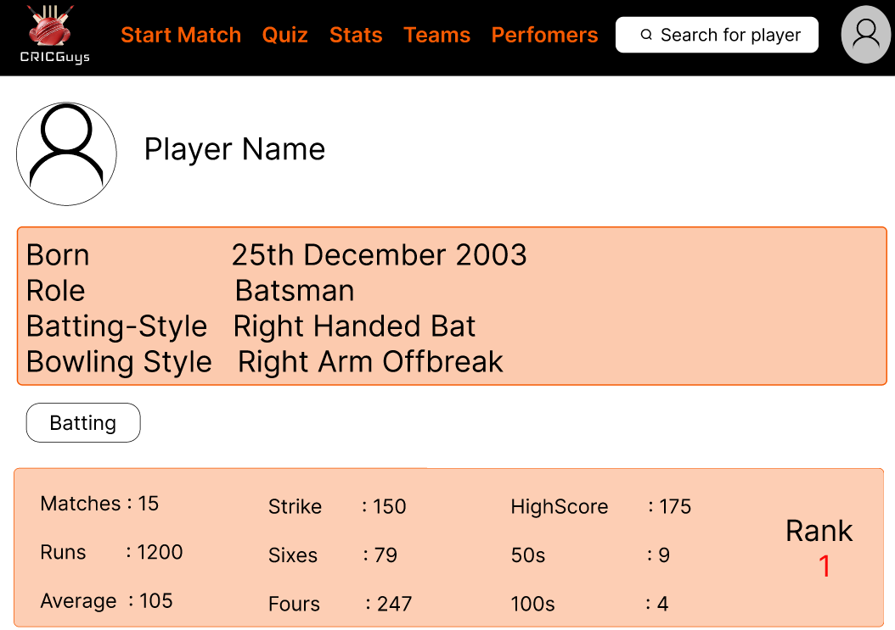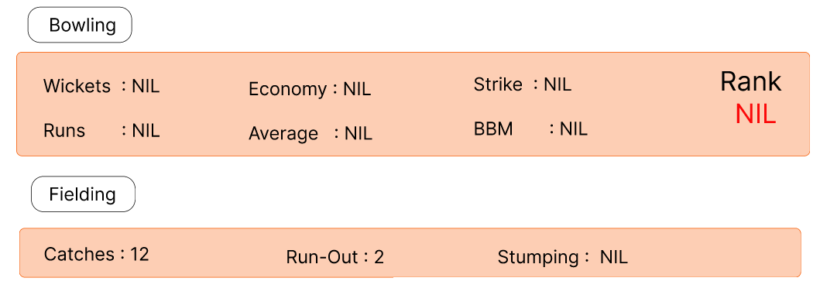

Scoring Page

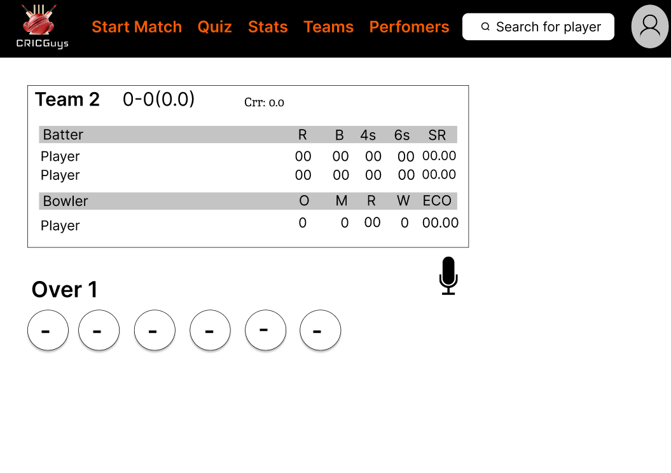
You can see the whole presentation of figma with
https://www.figma.com/file/MvZgO7lXW7azjkfzdAZQUt/Untitled?node-id=0%3A1

